**Experiment Results, Discussion and Conclusion**

1. **Experimental Results**

The circuit shows the system prototype in operation and component connection. All components are connected to a ESP8266 WIFI module that enable connection to the internet.

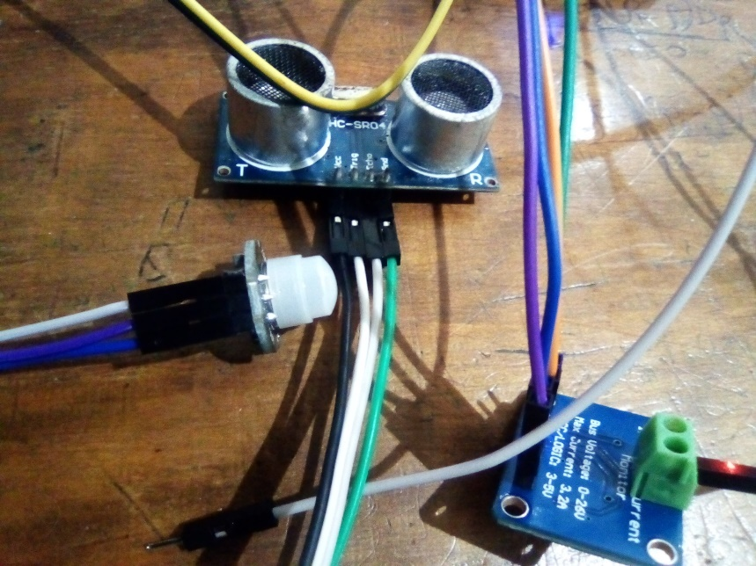The circuit below shows all the sensor used in developing the prototype. The sensor is used for perception purpose to enable real time monitoring of described utilities in a car wash business environment.

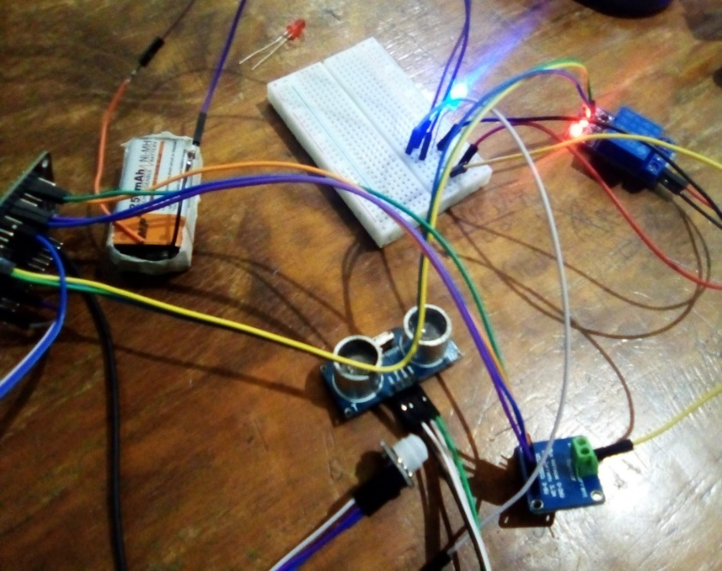The circuit below shows a whole system that is to be deployed. Battery is used to enable monitoring of the power that the load uses during operation. Relay is included into the system to enable automatic control of water in the tank. When the volume of water in the tank decrease, the relay is triggered to enable water flow into the tank. When the volume increases, the relay stops the inflow tap from filling the tank.

Figure shows prototype circuit.

INA219 sensor is used to enable monitoring of power consumption in the premise. PIR motion sensor monitors the number of cars entering the car wash through a count. Ultrasonic sensor is used to monitor water consumption.

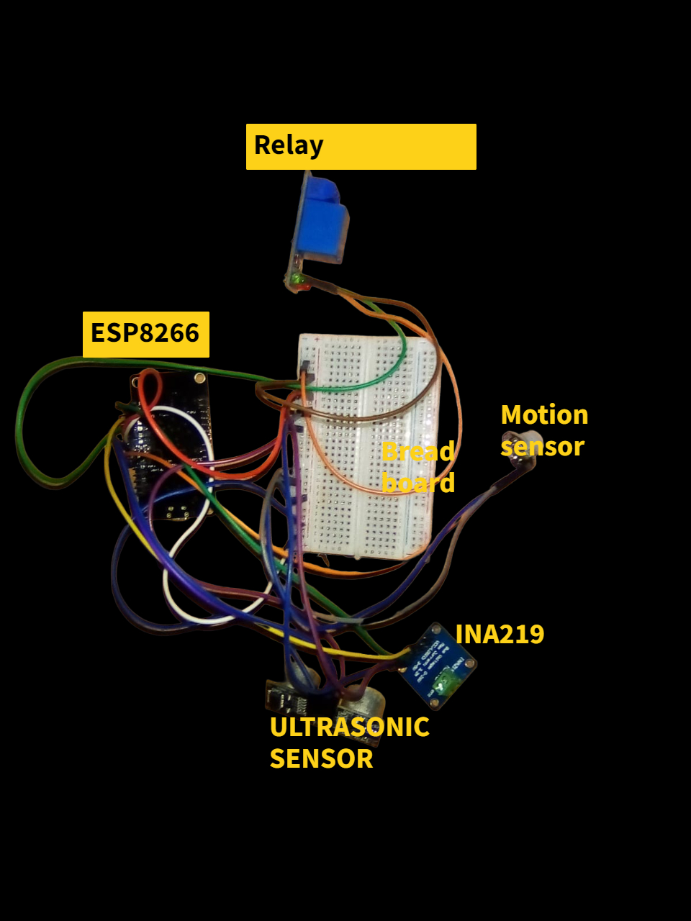

Schematic

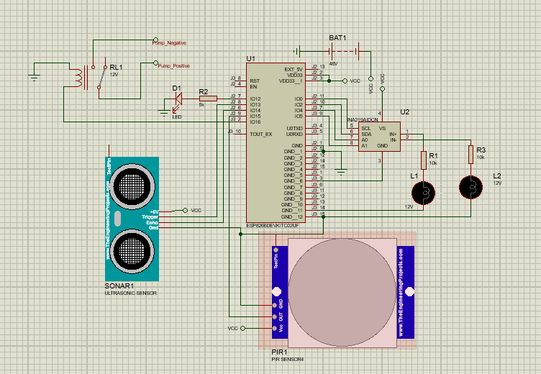

1. **Tank capacity**

The graph shows water usage from the tank and time progress. Real time monitoring of water consumption is necessary to ensure the water is always available for continuous running of business. Further is vital to monitor water consumption to reduce unnecessary usage or water loss by leaving the tank tap open.

Tank capacity is determined by the equation below:

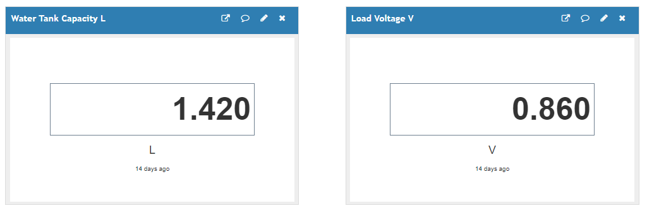

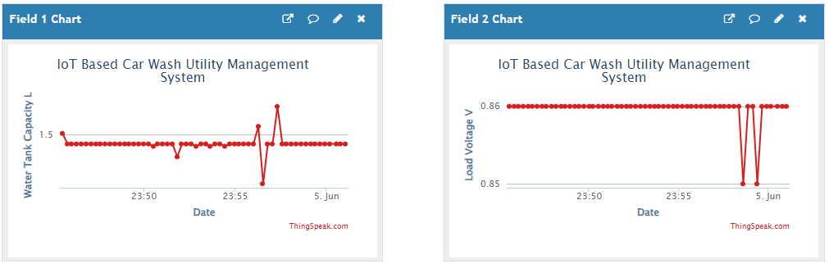

Graph showing real time water usage. Real water consumed value

1. **Load voltage**

The graph below shows voltage in the system during operation. Voltage remains constant during operation as shown in the graph. The exact value of voltage is displayed on the left side. This is vital to ensure real monitoring of load in the system is achieved.



1. **Current**

Current of the system will always change during operation of work being done. Load such as operating the pressure tank, pumping water, use power to run and operate. Graph below displays real time current variation of the system.

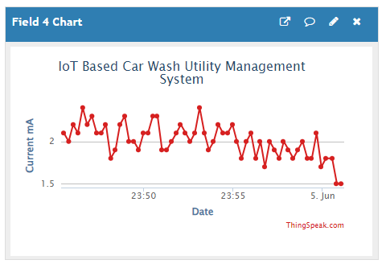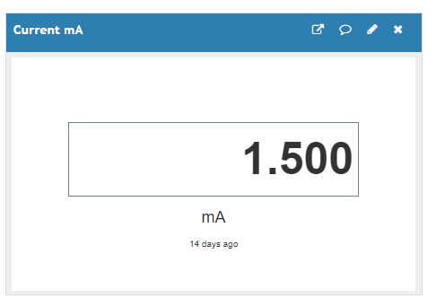

1. **Power usage**

Power is the rate at which energy is consumed or used. It can be determined from voltage and current or work done over time.

The graph below shows real time power usage and value display as the operation progresses.

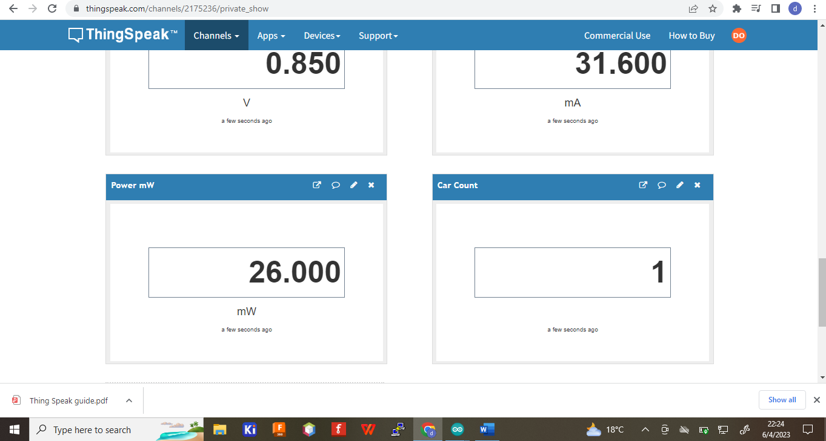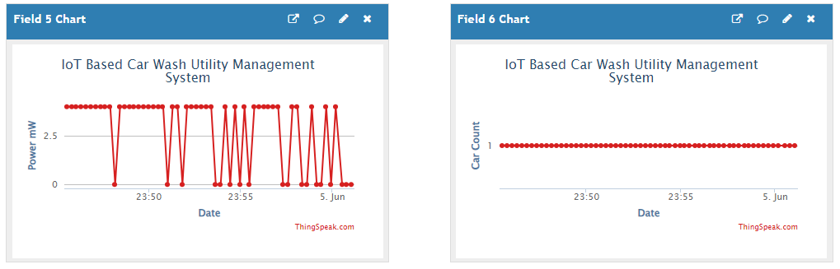

1. **Number of cars**

The count of number of cars serviced is important to ensure accountability for both resources and cash flow. It is important to ensure resources spend match the cash flow of the business. The graph shows real time display of car count and its real time value.

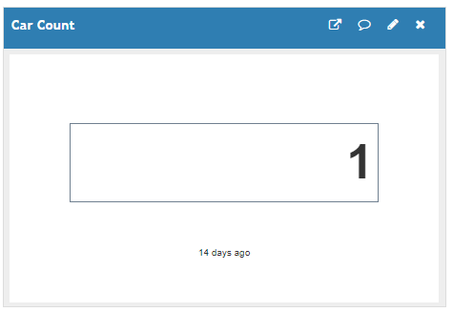

1. **Discussion**
2. Water Consumption Monitoring

The ultrasonic sensor measures the water flow rate or water level in the car wash system. To estimate the water consumption, the following equation is used:

The water flow rate is be calculated using the ultrasonic sensor data. By measuring the time taken for the ultrasonic waves to bounce back after hitting an object (such as water), we determine the distance traveled by the waves. With this information, we estimate the water flow rate based on the cross-sectional area of the water flow.

1. Power Consumption Monitoring

The INA219 sensor measures the current flowing through the car wash equipment. To calculate power consumption, we use the following equation:

The INA219 sensor provides measurements of current and voltage. By multiplying these two values, we obtain the power consumption in watts. This equation helps you monitor the energy usage of the car wash operation.

1. Car Count Monitoring

The motion sensor detects the presence of a car passing through a specific area or entering the car wash bay. By counting the number of car motions, we track the number of cars washed. This count can be obtained directly from the motion sensor and used for various analyses and reporting purposes.

1. Displaying Results using Thingspeak

Thingspeak is an IoT analytics platform that allows you to visualize and display the sensor data in real-time. Sending the sensor data to Thingspeak, we create channels and configure visualizations to showcase the monitored parameters. The visualizations are customized the to present water consumption, power consumption, and car count data using graphs, charts, or numerical displays.

1. Data security

Data being send to Thingspeak from the sensors is well protected encrypted through an autogenerated API Key that is generated when creating a channel on the platform. Reading and writing of data from and to channel is enabled in a private form to guarantee high security. Snips shown below shows the security features of API used to ensure data on the platform is always safe.

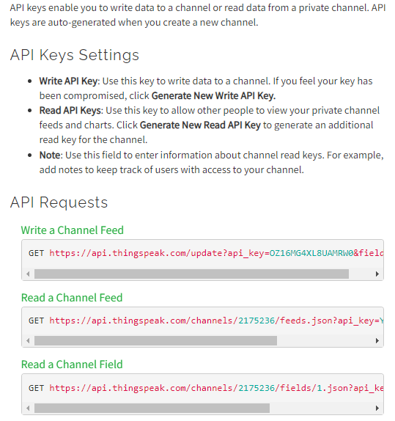

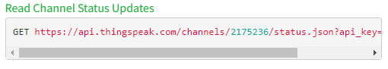

1. **Conclusion**

The IoT-based car wash utility management system, utilizing an ultrasonic sensor, INA219 sensor, motion sensor, and Thingspeak platform, offers several benefits for monitoring and optimizing car wash operations. By monitoring water consumption, power consumption, and the number of cars washed, the system provides valuable insights and enables informed decision-making. Here's a summary of the key points:

* Water Consumption Monitoring: The ultrasonic sensor measures water flow rate or level, allowing for accurate estimation of water consumption. This information helps in identifying water usage patterns, optimizing water resources, and promoting water conservation.
* Power Consumption Monitoring: The INA219 sensor measures current and voltage, facilitating the calculation of power consumption. Monitoring energy usage patterns, the system aids in identifying opportunities for energy efficiency improvements and cost reductions.
* Car Count Monitoring: The motion sensor detects the presence of cars passing through specific areas, enabling accurate counting of the number of cars washed. This data assists in analyzing car wash performance, identifying peak hours, and generating reports for operational evaluation.
* Thingspeak Integration: Thingspeak serves as the cloud-based IoT analytics platform, where sensor data is collected, stored, analyzed, and visualized in real-time. Through customizable visualizations and widgets, Thingspeak allows for clear and intuitive representation of water consumption, power consumption, and car count data.

Overall, the IoT-based car wash utility management system enhances efficiency, reduces costs, and promotes sustainability in car wash operations. By leveraging sensor technology, data analytics, and visualization capabilities, the system empowers car wash facility managers to make informed decisions, optimize resource utilization, and improve overall performance.